**STEP UP AND STEP DOWN CONVERTERS**

**1.Stepping Up and Stepping Down AC**

**2.Stepping Up and Stepping Down DC**

1.FOR AC CONVERSION

Transformers are generally devices which are used to generally step up and step down voltages

In case of ac power.

We use transformers for stepping up or steeping down the voltage,a transformer is a device which works on the principle of mutual induction.There are two types of transformers available in market:

**1.Step Up Transformer(which is used to step up or increase the voltage)**

**2.Step Down Transformer(which is used to decrease the voltage)**

1.Step up Transformer:In Step up transformer secondary coil winding is more than primary coil winding,therefore larger voltage is generated due to mutual induction,as larger voltage is generated due to mutual inductance so we can say that it has step up the voltage as flux generated is directly proportional to the number of turns made by the coil and current is more as Power is conserved and P=V*I

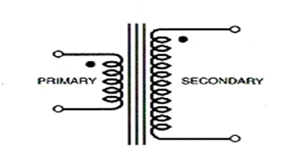

2.Step Down Transformer:In Step down transformer secondary coil winding is less than primary coil winding so it is used to step down the voltage as we obtain the required output voltage which is less than the applied input voltage as flux generated is less therefore the output voltage is less and current generated is more as it Power remains conserved so the Current is more(As P=V*I)

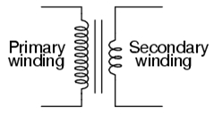

**2.FOR DC CONVERSION**

BUCK BOOST CONVERTER:A buck boost converter is used to step up or step down the DC voltage.

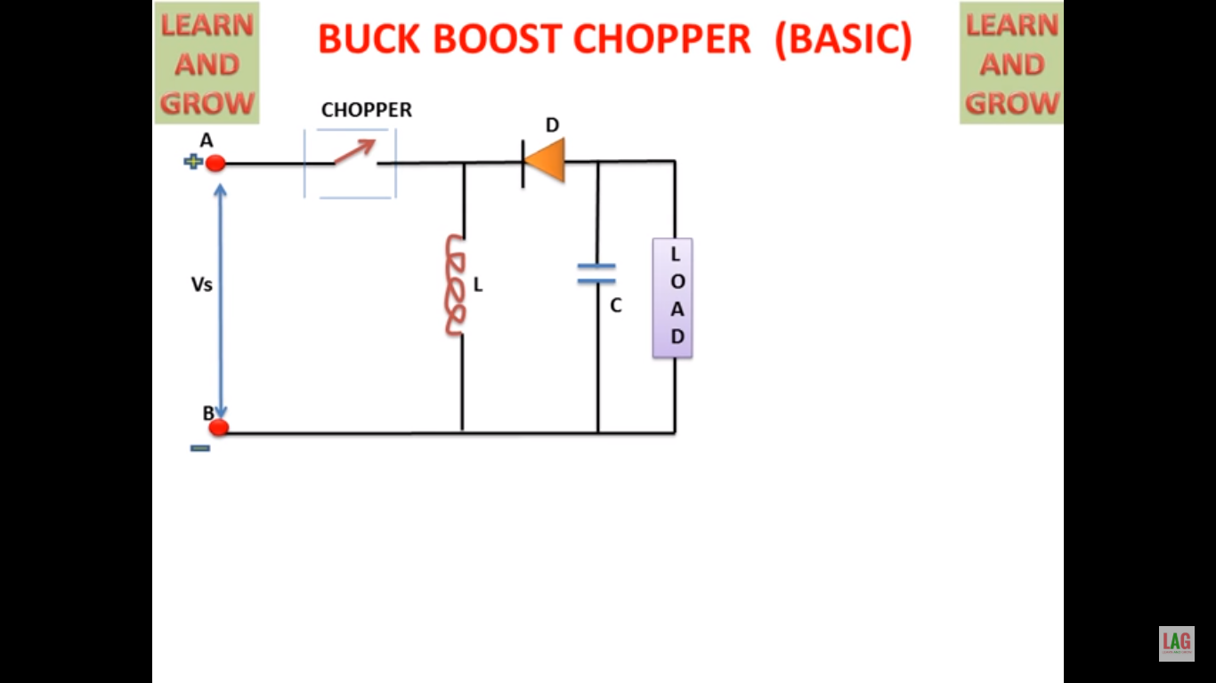

Diagram Taken From Youtube

When Switch is off then:

Then the current flows through the inductor as the current passes through the inductor magnetic field is generated around the inductor and the current flows through the load as diode is reversed biased current does not flow through the diode.

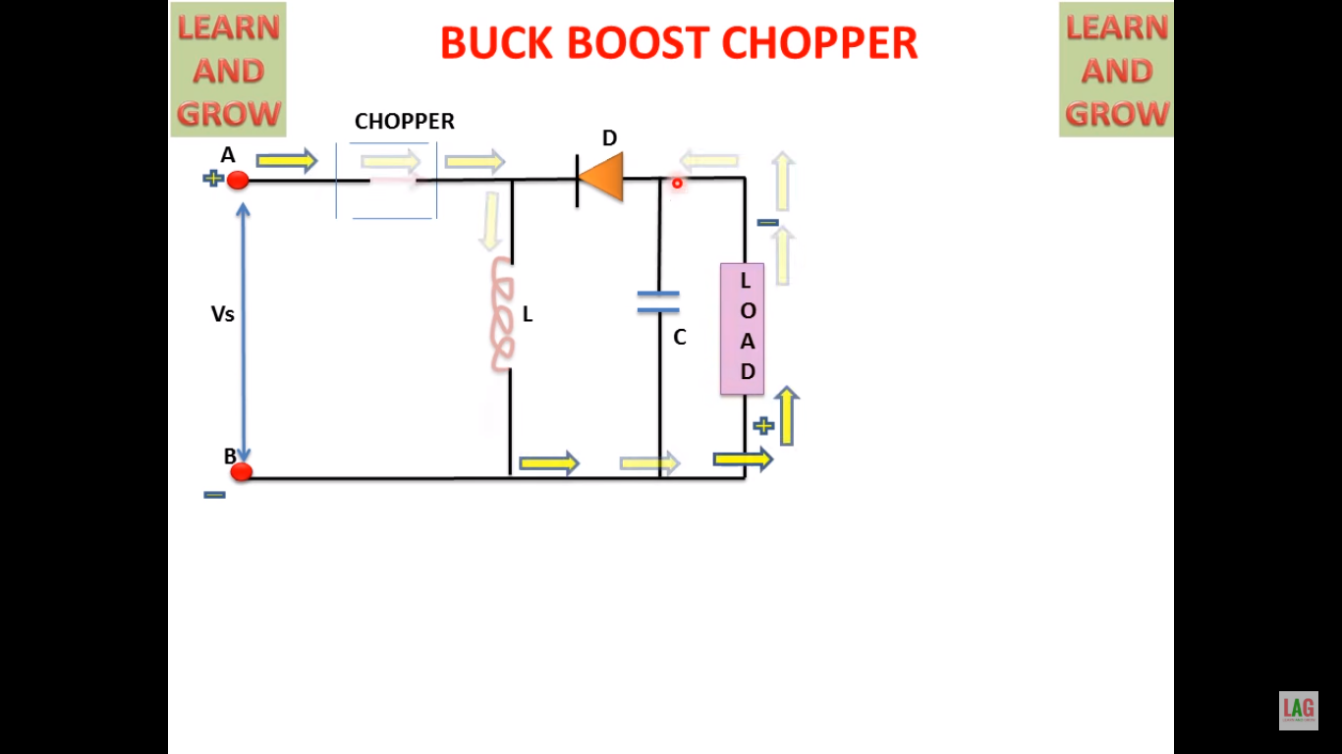

I=1/l*integeration(V.dt)

When switch is on then:

The the current does not flow as a result the inductor which has stored current discharges and allow the flow of current therefore the net current decreases



I=-1/l*integeration(Voutpt*dt)

**GRAPH OF INUT AND OUTPUT CURENT AND VOLTAGE**

